Contents

|  |  |  |
| --- | --- | --- |
| 1. **No.** | **Contents** | **Page** |
| **1.** | **Certificate** | **1** |
| **2.** | **Acknowledgement** | **2** |
| **3.** | **Introduction** | **3** |
|  | **Periodic Table** | **4 - 5** |
|  | **Program** | **6 - 7** |
| **6.** | **Output** | **8 - 9** |
| **7.** | **Text Files** | **10 - 14** |
| **8.** | **Conclusion** | **15** |
| **9.** | **Bibliography** | **16** |

Acknowledgement

*I would like to express my sincere and heartfelt gratitude to my Computer Sir, Mr. Dilip Kumar, who has helped me in this endeavour and has always been very co-operative - and without his help and co-operation, guidance and encouragement, the project couldn’t have been evolved to be.*

*I am also thankful to my family members to be always supporting me throughout the times.*

*Al last, I would also express my gratitude to my friends who co-operated with me.*

Introduction

Periodic Table

Program :

from tabulate import tabulate

f1 = open("Periodic_Table1.txt","r")

f2 = open("Periodic_Table2.txt","r")

l1 = f1.read().split("\n")

l = []

for i in l1:

    x = i.split(",")

    l.append(x)

l2 = f2.read().split("\n")

lst = []

for i in l2:

    x = i.split(",")

    lst.append(x)

for i in range(1,8):

    l[i-1].insert(0,i)

table1 = tabulate(l[:7], headers=[i for i in range(1,19)], tablefmt="grid")

table2 = tabulate(l[7:], tablefmt="grid")

print("Periodic Table :-\n")

print(table1,"\n")

print(table2)

print("Note : These have Group no. 3 and Period no. 4 & 5")

details = ["Name","Atomic Number","Type of element","Group Number","Period Number","Block","Atomic Mass","State of element","Density (in gm/cc)","Electronegativity","Electronic Configuration","Symbol"]

while True:

    print(f"\n{'-'*140}\n")

    s = input("Enter the symbol, or atomic number, or name of the element (Press 'quit' to exit) : ").capitalize()

    print()

    for i in lst:

        if (i[-1] == s or (i[0] == s) or (i[1] == s)):

            for j in range(-1,11):

                print(f"{details[j]} : {i[j]}")

    if s == "Quit":

        break

f1.close()

f2.close()

Output

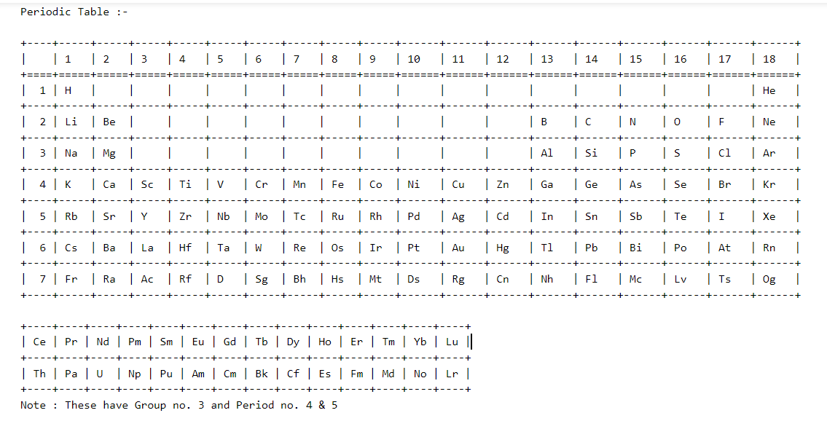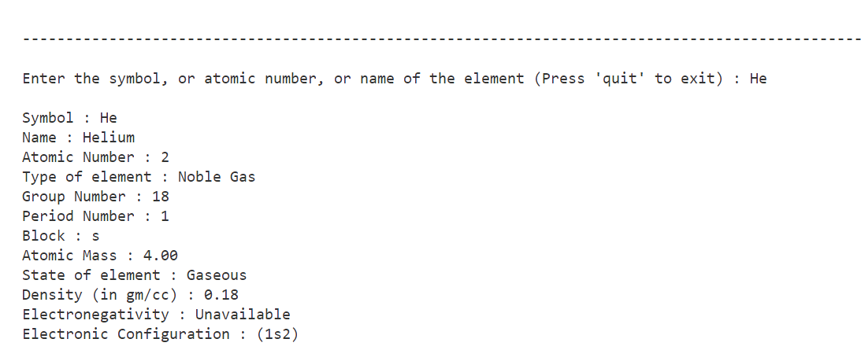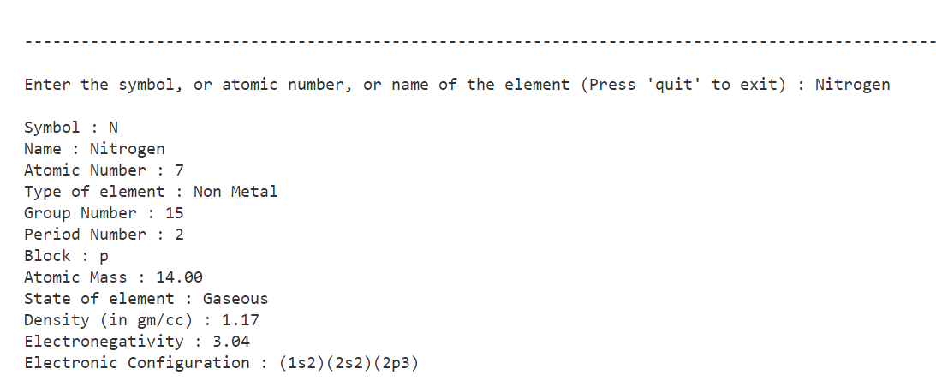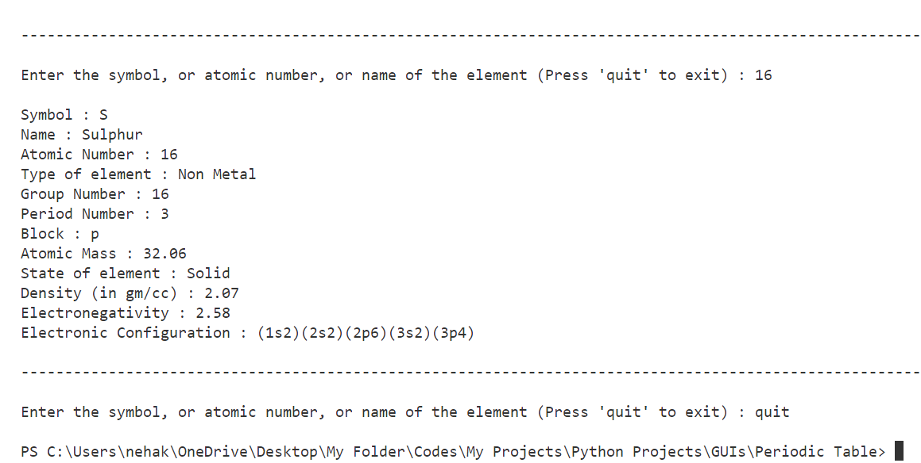

Text Files :

Periodic_Table1.txt :

H,,,,,,,,,,,,,,,,,He

Li,Be,,,,,,,,,,,B,C,N,O,F,Ne

Na,Mg,,,,,,,,,,,Al,Si,P,S,Cl,Ar

K,Ca,Sc,Ti,V,Cr,Mn,Fe,Co,Ni,Cu,Zn,Ga,Ge,As,Se,Br,Kr

Rb,Sr,Y,Zr,Nb,Mo,Tc,Ru,Rh,Pd,Ag,Cd,In,Sn,Sb,Te,I,Xe

Cs,Ba,La,Hf,Ta,W,Re,Os,Ir,Pt,Au,Hg,Tl,Pb,Bi,Po,At,Rn

Fr,Ra,Ac,Rf,D,Sg,Bh,Hs,Mt,Ds,Rg,Cn,Nh,Fl,Mc,Lv,Ts,Og

Ce,Pr,Nd,Pm,Sm,Eu,Gd,Tb,Dy,Ho,Er,Tm,Yb,Lu

Th,Pa,U,Np,Pu,Am,Cm,Bk,Cf,Es,Fm,Md,No,Lr

Periodic_Table2.txt :

Hydrogen,1,Non Metal,1,1,s,1.01,Gaseous,0.08,2.2,(1s1),H

Helium,2,Noble Gas,18,1,s,4.00,Gaseous,0.18,Unavailable,(1s2),He

Lithium,3,Alkaline Metal,1,2,s,6.94,Solid,0.53,0.98,(1s2)(2s1),Li

Beryllium,4,Alkaline Earth Metal,2,2,s,9.01,Solid,1.84,1.57,(1s2)(2s2),Be

Boron,5,Metalloid,13,2,p,10.81,Solid,2.46,2.04,(1s2)(2s2)(2p1),B

Carbon,6,Non Metal,14,2,p,12.01,Solid,2.26,2.55,(1s2)(2s2)(2p2),C

Nitrogen,7,Non Metal,15,2,p,14.00,Gaseous,1.17,3.04,(1s2)(2s2)(2p3),N

Oxygen,8,Non Metal,16,2,p,15.99,Gaseous,1.43,3.44,(1s2)(2s2)(2p4),O

Fluorine,9,Halogen,17,2,p,18.99,Gaseous,1.70,3.98,(1s2)(2s2)(2p5),F

Neon,10,Noble Gas,18,2,p,20.17,Gaseous,0.90,Unavailable,(1s2)(2s2)(2p6),Ne

Sodium,11,Alkaline Metal,1,3,s,22.99,Solid,0.97,0.93,(1s2)(2s2)(2p6)(3s1),Na

Magnesium,12,Alkaline Earth Metal,2,3,s,24.31,Solid,1.74,1.31,(1s2)(2s2)(2p6)(3s2),Mg

Aluminium,13,Metal,13,3,p,26.98,Solid,2.69,1.61,(1s2)(2s2)(2p6)(3s2)(3p1),Al

Silicon,14,Metalloid,14,3,p,28.08,Solid,2.34,1.90,(1s2)(2s2)(2p6)(3s2)(3p2),Si

Phosphorus,15,Non Metal,15,3,p,30.97,Solid,2.4,2.19,(1s2)(2s2)(2p6)(3s2)(3p3),P

Sulphur,16,Non Metal,16,3,p,32.06,Solid,2.07,2.58,(1s2)(2s2)(2p6)(3s2)(3p4),S

Chlorine,17,Halogen,17,3,p,35.45,Gaseous,3.22,3.16,(1s2)(2s2)(2p6)(3s2)(3p5),Cl

Argon,18,Noble Gas,18,3,p,39.95,Gaseous,1.78,Unavailable,(1s2)(2s2)(2p6)(3s2)(3p6),Ar

Potassium,19,Alkaline Metal,1,4,s,39.09,Solid,0.86,0.82,(1s2)(2s2)(2p6)(3s2)(3p6)(4s1),K

Calcium,20,Alkaline Earth Metal,2,4,s,40.08,Solid,1.55,1.00,(1s2)(2s2)(2p6)(3s2)(3p6)(4s2),Ca

Scandium,21,Transition Metal,3,4,d,44.96,Solid,2.99,1.36,...,Sc

Titanium,22,Transition Metal,4,4,d,47.87,Solid,4.5,1.54,...,Ti

Vanadium,23,Transition Metal,5,4,d,50.94,Solid,6.11,1.63,...,V

Chromium,24,Transition Metal,6,4,d,51.99,Solid,7.14,1.66,...,Cr

Manganese,25,Transition Metal,7,4,d,54.94,Solid,7.43,1.55,...,Mn

Iron,26,Transition Metal,8,4,d,55.85,Solid,7.87,1.83,...,Fe

Cobalt,27,Transition Metal,9,4,d,58.93,Solid,8.90,1.88,...,Co

Nickel,28,Transition Metal,10,4,d,58.69,Solid,8.90,1.91,...,Ni

Copper,29,Transition Metal,11,4,d,63.54,Solid,8.92,1.90,...,Cu

Zinc,30,Transition Metal,12,4,d,65.38,Solid,7.14,1.65,...,Zn

Gallium,31,Metal,13,4,p,69.72,Solid,5.90,1.81,...,Ga

Germanium,32,Metalloid,14,4,p,72.63,Solid,5.32,2.01,...,Ge

Arsenic,33,Metalloid,15,4,p,74.92,Solid,5.73,2.18,...,As

Selenium,34,Metalloid,16,4,p,78.97,Solid,4.82,2.55,...,Se

Bromine,35,Halogen,17,4,p,79.90,Liquid,3.12,2.96,...,Br

Krypton,36,Noble Gas,18,4,p,83.80,Gaseous,3.75,3.00,...,Kr

Rubidium,37,Alkaline Metal,1,5,s,85.47,Solid,1.53,0.82,...,Rb

Strontium,38,Alkaline Earth Metal,2,5,s,87.62,Solid,2.63,0.95,...,Sr

Yttrium,39,Transition Metal,3,5,d,88.91,Solid,4.47,1.22,...,Y

Zirconium,40,Transition Metal,4,5,d,91.22,Solid,6.50,1.33,...,Zr

Niobium,41,Transition Metal,5,5,d,92.90,Solid,8.57,1.6,...,Nb

Molybednium,42,Transition Metal,6,5,d,95.95,Solid,10.28,2.16,...,Mo

Technetium,43,Transition Metal,7,5,d,98.90,Solid,11.5,1.9,...,Tc

Ruthenium,44,Transition Metal,8,5,d,101.07,Solid,12.37,2.2,...,Ru

Rhodium,45,Transition Metal,9,5,d,102.90,Solid,12.38,2.28,...,Rh

Palladium,46,Transition Metal,10,5,d,106.42,Solid,11.99,2.20,...,Pd

ilver,47,Transition Metal,11,5,d,107.87,Solid,10.49,1.93,...,Ag

Cadmium,48,Transition Metal,12,5,d,112.41,Solid,8.65,1.69,...,Cd

Indium,49,Metal,13,5,p,114.82,Solid,7.31,1.78,...,In

Tin,50,Metal,14,5,p,118.71,Solid,5.77,1.96,...,Sn

Antimony,51,Metalloid,15,5,p,121.76,Solid,6.70,2.05,...,Sb

Tellurium,52,Metalloid,16,5,p,127.60,Solid,6.24,2.10,...,Te

Iodine,53,Halogen,17,5,p,126.90,Solid,4.94,2.66,...,I

Xenon,54,Noble Gas,18,5,p,131.29,Gaseous,5.90,2.6,...,Xe

Caesium,55,Alkaline Metal,1,6,s,132.91,Solid,1.90,0.79,...,Cs

Barium,56,Alkaline Earth Metal,2,6,s,137.33,Solid,3.62,0.89,...,Ba

Lanthanum,57,Transition Metal,3,6,d,138.90,Solid,6.17,1.1,...,La

Cerium,58,Lanthanide,La,6,f,140.12,Solid,6.77,1.12,...,Ce

Praseodymium,59,Lanthanide,La,6,f,140.91,Solid,6.48,1.13,...,Pr

Neodymium,60,Lanthanide,La,6,f,144.24,Solid,7.00,1.14,...,Nd

Promethium,61,Lanthanide,La,6,f,146.91,Solid,7.2,Unavailable,...,Pm

Samarium,62,Lanthanide,La,6,f,150.36,Solid,7.54,1.17,...,Sm

Europium,63,Lanthanide,La,6,f,151.96,Solid,5.25,Unavailable,...,Eu

Gadolinium,64,Lanthanide,La,6,f,157.25,Solid,7.89,1.20,...,Gd

Terbium,65,Lanthanide,La,6,f,158.93,Solid,8.25,Unavailable,...,Tb

Dysprosium,66,Lanthanide,La,6,f,162.50,Solid,8.56,1.22,...,Dy

Holmium,67,Lanthanide,La,6,f,164.93,Solid,8.78,1.23,...,Ho

Erbium,68,Lanthanide,La,6,f,167.26,Solid,9.05,1.24,...,Er

Thulium,69,Lanthanide,La,6,f,168.93,Solid,9.32,1.25,...,Tm

Ytterbium,70,Lanthanide,La,6,f,173.05,Solid,6.97,Unavailable,...,Yb

Lutetium,71,Lanthanide,La,6,f,174.97,Solid,9.84,1.27,...,Lu

Hafnium,72,Transition Metal,4,6,d,178.49,Solid,13.28,1.3,...,Hf

Tantalum,73,Transition Metal,5,6,d,180.95,Solid,16.65,1.5,...,Ta

Tungsten,74,Transition Metal,6,6,d,183.84,Solid,19.25,2.36,...,W

Rhenium,75,Transition Metal,7,6,d,186.21,Solid,21.00,1.9,...,Re

Osmium,76,Transition Metal,8,6,d,190.23,Solid,22.59,2.2,...,Os

Irdium,77,Transition Metal,9,6,d,192.22,Solid,22.56,2.2,...,Ir

Platinum,78,Transition Metal,10,6,d,195.08,Solid,21.45,2.2,...,Pt

Gold,79,Transition Metal,11,6,d,196.97,Solid,19.32,2.54,...,Au

Mercury,80,Transition Metal,12,6,d,200.59,Liquid,13.55,2.00,...,Hg

Thalium,81,Metal,13,6,p,204.38,Solid,11.85,1.62,...,Tl

Lead,82,Metal,14,6,p,207.20,Solid,11.34,2.33,...,Pb

Bismuth,83,Metal,15,6,p,208.98,Solid,9.78,2.02,...,Bi

Polonium,84,Metal,16,6,p,209.98,Solid,9.20,2.0,...,Po

Astatine,85,Halogen,17,6,p,209.99,Solid,Unavailable,2.2,...,At

Radon,86,Noble Gas,18,6,p,222.00,Gaseous,9.73,Unavailable,...,Rn

Francium,87,Alkaline Metal,1,7,s,223.02,Solid,Unavailable,0.7,...,Fr

Radium,88,Alkaline Earth Metal,2,7,s,226.03,Solid,5.5,0.9,...,Ra

Actinium,89,Transition Metal,3,7,d,227.03,Solid,10.07,1.1,...,Ac

Thorium,90,Actinide,Ac,7,f,232.04,Solid,11.72,1.3,...,Th

Protactinium,91,Actinide,Ac,7,f,231.04,Solid,15.37,1.5,...,Pa

Uranium,92,Actinide,Ac,7,f,238.03,Solid,19.16,1.3,...,U

Neptunium,93,Actinide,Ac,7,f,237.05,Solid,20.45,1.36,...,Np

Plutonium,94,Actinide,Ac,7,f,244.06,Solid,19.82,1.28,...,Pu

Americium,95,Actinide,Ac,7,f,243.06,Solid,13.67,1.3,...,Am

Curium,96,Actinide,Ac,7,f,247.07,Solid,13.51,1.3,...,Cm

Berkelium,97,Actinide,Ac,7,f,247,Solid,14.78,1.3,...,Bk

Californium,98,Actinide,Ac,7,f,251,Solid,15.1,1.3,...,Cf

Einsteinium,99,Actinide,Ac,7,f,252,Solid,8.84,Unavailable,...,Es

Fermium,100,Actinide,Ac,7,f,257.10,Solid,Unavailable,Unavailable,...,Fm

Medelevium,101,Actinide,Ac,7,f,258,Solid,Unavailable,Unavailable,...,Md

Nobelium,102,Actinide,Ac,7,f,259,Solid,Unavailable.,Unavailable,...,No

Lawrencium,103,Actinide,Ac,7,f,266,Solid,Unavailable,Unavailable,...,Lr

Rutherfordium,104,Transition Metal,4,7,d,261.11,Solid,17.00,Unavailable,...,Rf

Dubnium,105,Transition Metal,5,7,d,262.11,Unavailable,Unavailable,Unavailable,...,D

Seaborgium,106,Transition Metal,6,7,d,263.12,Unavailable,Unavailable,Unavailable,...,Sg

Bohrium,107,Transition Metal,7,7,d,262.12,Unavailable,Unavailable,Unavailable,...,Bh

Hassium,108,Transition Metal,8,7,d,265,Unavailable,Unavailable,Unavailable,...,Hs

Meitnerium,109,Unknown,9,7,d,268,Unavailable,Unavailable,Unavailable,...,Mt

Darmstadtium,110,Unknown,10,7,d,281,Unavailable,Unavailable,Unavailable,...,Ds

Roentgenium,111,Unknown,11,7,d,280,Unavailable,Unavailable,Unavailable,...,Rg

Copernicium,112,Unknown,12,7,d,277,Unavailable,Unavailable,Unavailable,...,Cn

Nihonium,113,Unknown,13,7,p,287,Unavailable,Unavailable,Unavailable,...,Nh

Flerovium,114,Unknown,14,7,p,289,Unavailable,Unavailable,Unavailable,...,Fl

Moscovium,115,Unknown,15,7,p,288,Unavailable,Unavailable,Unavailable,...,Mc

Livermorium,116,Unknown,16,7,p,293,Unavailable,Unavailable,Unavailable,...,Lv

Tennessine,117,Unknown,17,7,p,292,Unavailable,Unavailable,Unavailable,...,Ts

Oganesson,118,Unknown,18,7,p,294,Solid,6.6,Unavailable,...,Og

Conclusion

Bibliography